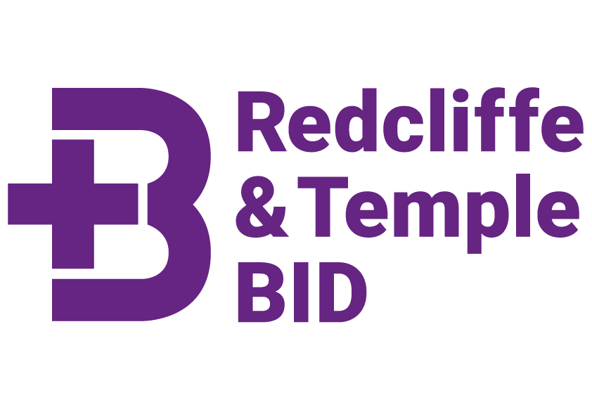

Actions and meeting notes from the
Redcliffe & Temple BID
Advisory Board meeting
16th March 2022 – 10am – TLT offices.

 | Attendees
Present: | Steve Bluff Redcliffe and Temple BID  Tom Swithinbank, Redcliffe & Temple BID  Chris Swift, Spicer & Cole  Helen Richardson, WSP  Imran Ali, Doubletree by Hilton  Jason Thorne, Bristol City Council  Joy Simmonds, Barclays  Keith Rundle, Director of BIDs, Visit West  Matt Grimwood, TLT  Paul Williams, Avison Young  Phil Hodgson, Arup  Victoria Matthews, Business West  William Juckes, Clarke Willmott
Apologies | Amy Simpson, Burges Salmon  Cllr Ani Stafford-Townsend  Charlotte Raynes, DAS  Cllr Farah Hussain  Jon Bower, WBD (Chair)

Meeting Actions

- Steve – Meet with Councillors Ani Stafford-Townsend and Farrah Hussain to update them on the BID’s progress to date.
- Beth – Create a website directory for professional services businesses.
- Beth – Consider BID posters for the area/offices to advertise the BID/newsletter with QR code to sign up.
- Beth – Promote newsletter sign up on social media again.
- Steve – Follow up with Chris Swift regarding movement data around Finzels Reach
- Steve – Meet with Victoria Matthews/Business West to discuss movement and spend data
- Steve and Jon – Continue to work through levy collection rates challenge, offer of support from Matthew Grimwood/TLT
- Tom – Share Portwall Lane and Rivergate visuals with the Board
- Tom – Share final Public Realm Strategy with Board
- Tom – Share Public Realm Working Group opportunities with Board
- Board Members – Continued support on social media is appareicated, please share newsletter with Bristol employees where possible.

Meeting Notes

1 | Welcome, introductions and apologies
- All were welcomed to the first ‘in person’ Redcliffe & Temple BID Advisory Board meeting, chaired by Steve Bluff.
Steve welcomed Imran as the new Vice Chair.
- Apologies were noted and are recorded above.
The Board agreed that the format of the Performance Report was a useful way of sharing information and progress to date.
2 | Project Delivery since 1st January
- Steve updated the team regarding cleansing progress, concerns raised about the level of tagging and graffiti with the Board encouraging the BID to continue work with the Police to find culprits.
- Tom explained the BIDs position on the Victoria Street consultation. Points raised regarding the naming of the consultation and relative lack of opportunities to engage meant it missed many people. Jason to feedback to Transport team.
- Steve updated on marketing progress and increasing reach of the BID via the newsletter, much improved new website and social media.
Ideas put forward to increase newsletter reach included posters in offices to encourage people to sign up. Thanks to the Board for support on social media, especially LinkedIn.
- Dr Bike continues to be a great success with 180 bikes serviced. Tom to update Board on ‘attendee survey’ outcomes which might help understand the wider impact of Dr Bike.
As with the Historic Walking Tours, Dr Bike is a useful gauge of the BID’s reach and which levy payers are sharing our newsletters.
- The Board agreed that the Bristol Light Festival had been a huge success and would welcome its repeat in the future.
The Board asked Steve to pass on thanks and praise to all involved.
Joy really enjoyed the ‘Meet the artists’ event at Left-Handed Giant and thanked us for organising that.
Questions asked around peak times, ownership of installations. Suggestion made of starting/ending the festival in half term in future.
- Tom outlined the success of the Public Realm Workshops and Walks and noted that Exeter BID had visited to learn more about this project.
(Report to be shared with the Board, April 22). In February, Tom presented to the Business West Planning, Transport and Climate Change Group about the work of the three BIDs in this field.
3 | Planned Projects
- Love Bristol Gift Card
- Steve outlined the plan for the Love Bristol Gift Card and explained the rationale behind the scheme for both the B2C and B2B markets. The Board agreeed it would support post COVID recovery and increase loyalty to local buinesses acrocss the City. The scheme is scheduled to launch in June 2022.
- Public Realm Improvements
- Tom explained that the BID has applied for Community Infrastructure Levy (CIL) funding for:
- Temple Way Underpass (£300k) – Key pedestrian and cycling route across the City Centre in need of improvements.
The importance of this route will increase as developments are completed. The BID will fund consultation and engagement subject to the application meeting the Stage 1 CIL funding criteria.
The Board were very supportive of our desire to improve this key route and commented that the area currently feels very unsafe, particularly for women. The Board agreed that this application should be the priority for the BID (of the three applications).
- Portwall Lane (£200k) – Small underused green space in the city centre, close to many large office blocks. The BID would like to make simple changes to open up the park from the Portwall Lane side.
The Board supported this approach and agreed that the park needed changes to give it more of a purpose.
- Temple Gardens (£75k) – The BID is partnering with English Heritage to make a CIL application for landscape works for the gardens. A further £725k will be provided by Lottery Funding and English Heritage. English Heritage are working with Bristol City Council on this programme with a view to taking on management of the gardens from Temple Garden,
The BID will also help to increase engagement with the consultation and design from our levy payers.
The Board agreed with this approach and felt that the park was an underused space and piece of history in the city.
- CIL Timeline: 31st May - Stage 1 decision, 18th September – Full Proposal Submission, November – Stage 2 decision.
- Temple Quay – Management Company have asked the BID to put forward some ideas to improve public space. Barton Willmore are helping us with this work.
- Public Realm Working Group
A Public Realm Working Group is to be formed in Summer 22. Interest has already been received from staff at Arcadis, WSP, Natural History Consortium, Bristol Rivers Trust and Forest of Avon Trust.
Tom to share experession of interest link with the Board.
- Lunchtime Activities
- Sabrina Shutter, BID Events Project Manager, is currently developing a programme of lunchtime events for local office staff. These will compliment the existing Historic Walking tours and include fitness classes, art classes and educational events.We continue to work through proposals for larger lunchtime events. Planning already started for Christmas!
- Building Managers Networking Event
- We recognise that the Building/Office Managers are key to delivering many of our projects and sharing information with tenants.
- Steve is working with three building managers to update our contact list and arrange a networking event for the summer.

- Winter Lights
- The winter lights in trees on Victoria Street have been well received by levy payers and residents. We expect to repeat this in September 2022. We awaiting a quote from our contractor regarding lighting for Temple Gardens. Lighting has been raised as a key concern by a number of levy payers (including the Hilton Garden Inn).

- Park Work
- Following the success of the Crocus bulb planting in February we are planning further sessions with the council’s Park Work team to enable staff to drop in on garding sessions in the BID area. These sessions will start with a date in April in Quaker Burial Ground.

- TAP for Bristol
- TAP for Bristol continues to be a great success with over £2,800 raised since TAP was established in Redcliffe & Temple in September. The TAP total is over £60,000 across the city.
Left Handed Giant continues to be the highest raising TAP point and our plan to move donation points around the offices seems to be productive.
We are planning more marketing to promote the window vinyl points as they are currently less successful.
- City Nature Challenge
- The BID is sponsoring the City Nature Challenge, taking place 29th April– 2nd May. This event encourages people to record nature they see across the city. Our sponsorship will fund nature based walks and a photo competition.
5 | BID Finance
- Levy collection rate for BID year 1 as at end February is 63%.
- The assumed collection rate is 85%
- This is 10% below the City Centre and Broadmead BIDs and is 30% below the pre-pandemic collection rate of 95%
- Steve explained that Jon Bower (as BID Chair) had written to John Savage (as Visit West Chair) to express his concern and support.
John Savage is currently looking into the issue with the senior team at Bristol City Council and is keen to explore this approach rather than exploring legal advice. Jon and Matt have offered their legal support if needed.
- The BID is on track with budgeted spend on the 5 themes of the business plan and is forecasting a carry forward of circa £50K into BID year 3, subject to the collection rate increasing in line with the forecasted 85%.

6 | AOB
 | - William thanked Keith for all his hard work for the BIDs over the years and wished Keith all the best for his retirement.
7 | Future meetings
7.1 Meetings will take place 4 times a year.
Next meeting date is:
Wednesday 15th June 2022 at 10am

Venue required, please contact Steve if you can help. (Barclays is unavailable)

